RIHAM AHAMED ABDUL RAHEEM

HND COMPUTING IDM

Documentation

Contents

**INTRODUCTION** 1

**INDEX** 1

**BINARY SEARCH** 2

**INSERTION SORT** 3

**OUTPUT** 3

**List of figure**

Figure 1: Index.java file screen shot 1

Figure 2: BinarySearvh.java file screen shot 2

Figure 3: InsertionSor.java file screen shot 3

Figure 4: BSandIS system output screen shot 3

# **INTRODUCTION**

I have chosen the Selection short data structure on an array to fit for my application for the Binary search and insertion sort as per the system.

The source code has not been included in this document as readability will be hindered. So I suggest opening index.java, BinarySearch.java, and InsertionSor.java in a suitable IDE or a text editor. Regardless, below I will include a few screenshots of the code and how it looks when it’s running. Please check all the pages.

# **INDEX**

Index is parent class file of BSandIS system. file name is index.java.

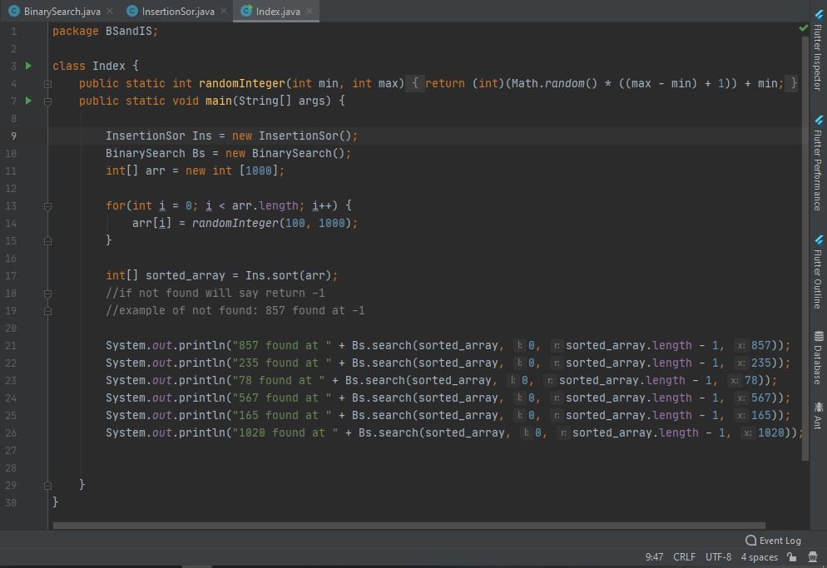

Figure 1: Index.java file screen shot

# **BINARY SEARCH**

Binary Search is children class file of BSandIS system. file name is BinarySearch.java.

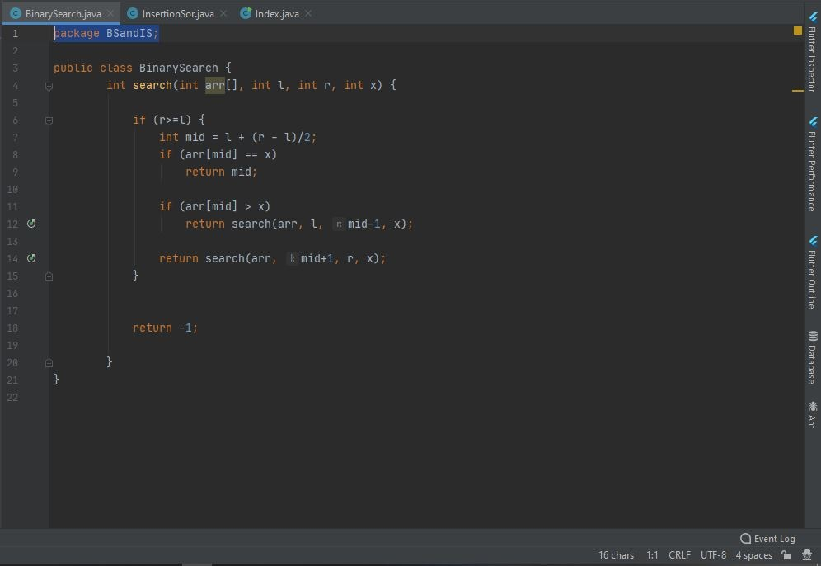

Figure 2: BinarySearvh.java file screen shot

# **INSERTION SORT**

Insertion sort also another children class file of BSandIS system. file name is InsertionSor.java

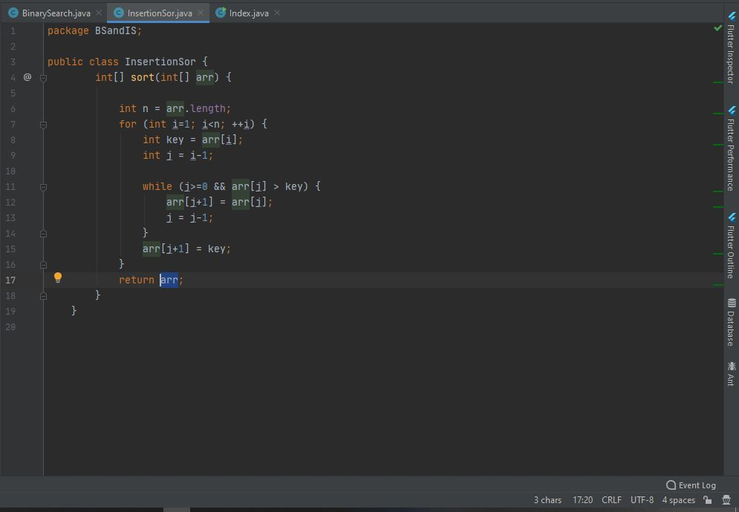

Figure 3: InsertionSor.java file screen shot

# **OUTPUT**

Figure 4: BSandIS system output screen shot